IDENTIFICATION OF SERVICES PROVIDED TO CLINICAL TRIAL PARTICIPANTS
PI:
Sponsor:
Study Title:

Using the clinical trial protocol schema, please indicate the clinical encounters, tests and/or procedures that are considered research-related and should be paid for by the study/sponsor (please circle all research-related charges on the protocol events/schema). In making your assessment, consider the following:
- The encounters, tests, and/or procedures are required for research purposes only as part of this clinical trial and are not part of routine care for patients with this medical condition.
- The sponsor of the trial is providing compensation for a service and, therefore, it is not considered billable to a subject and/or their third party.
The University of Arizona Health Sciences Center requires source documentation that shows the detail for all required study procedures and a determination of who is paying upfront and before the trial starts. The basis for this requirement is to complete a Payer Coverage Analysis and use the designation of procedures to ensure that the informed consent, external budget, internal budget, billing grid, and the clinical care expenses related to an active study all coincide to this process.
Per the CMS National Coverage Decision (Sept. 2000), only services considered routine costs of qualifying clinical trials are ‘billable” to Medicare. All coverage rules and payment requirements (i.e. local coverage decisions) must still be met. To be “billable” to the subject and/or their third party, all services considered routine/conventional care must meet the following criteria:

- The services are considered safe and effective based on authoritative evidence as generally accepted by the medical community.
- The services are considered medically necessary.
- The services are not unproven or experimental in nature.
- Supported by past billing practices.

Other Budget Related Items (please answer all questions):
- How many subjects do you plan to enroll?
- Will the UAHN Investigational Pharmacy be used? Yes ☐ No ☐ NA ☐
- Will UAHN Radiology Imaging Services be used? Yes ☐ No ☐ NA ☐
- Labs will be processed: Locally ☐ Sponsor’s central lab ☐
- Do you plan to provide subject compensation? Yes ☐ No ☐
If so, what is the total amount per study subject for the duration of the study? $
6. Will the study interactions occur: INPATIENT ☐ OUTPATIENT ☐ BOTH ☐
Your signature below will serve as your attestation that, following your review of the clinical trial protocol, all clinical services you expect to perform have been identified and labeled as either clinical trial/research-related or routine care.

PI Signature: Date

Epic Charge Validator Name (if no charges will be in Epic, study coordinator can sign):
____________________________________ (print name)

Signature: Date:

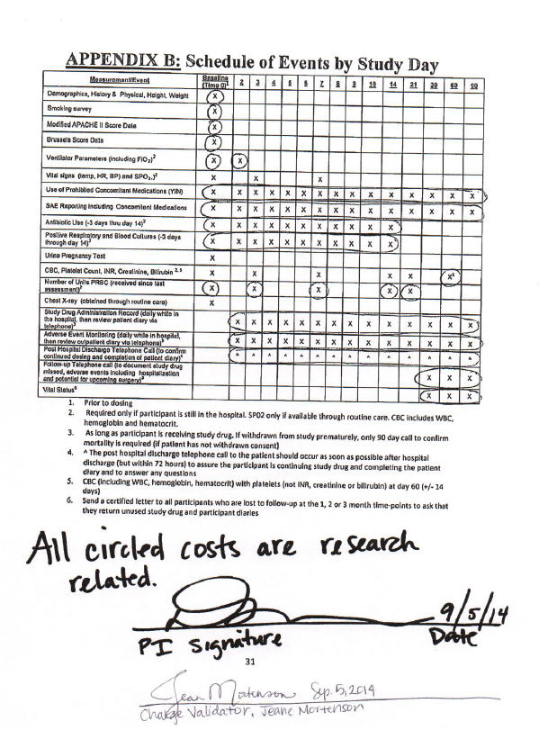
Sample

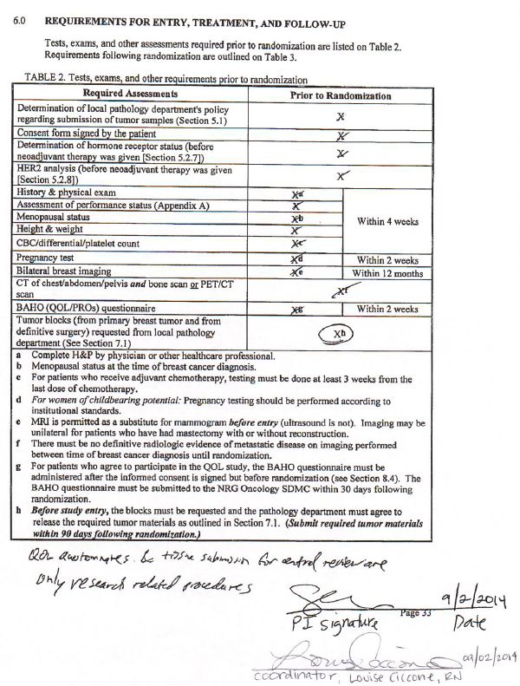
Sample

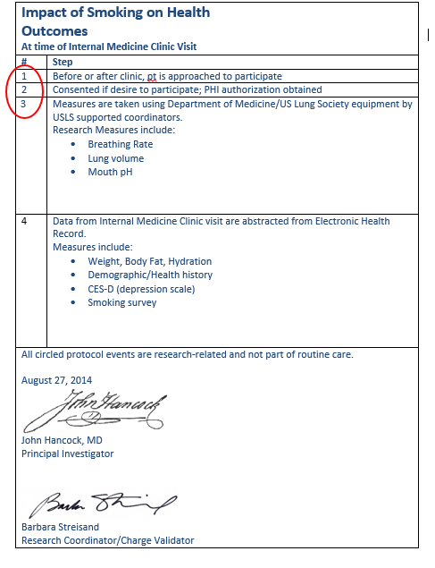
Sample

