YOUR CYSTIC FIBROSIS CLINIC NUTRITION ACTION PLAN
Name: ___________________________________________________________
Date of Clinic Visit: __________________________ Age: __________________
TODAY | GOAL
Weight __________lbs (_______%) ↑ ↓ ↔  Height __________ cm (_______%) ↑ ↓ ↔  BMI __________ (_______%) ↑ ↓ ↔  Weight/Length (<2 yrs old) _______% | __________ lbs  __________ expected weight gain  __________ BMI

Recommended Changes to Nutrition Plan:  □ Enzymes:  □ Nutrition Supplements:  □ Other: | Reviewed/Education:  □ Enzyme use and storage  □High calorie/high protein meal and snack ideas  □Food diary/24 hour recall

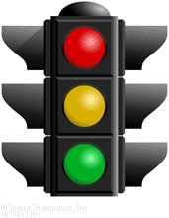 | Your Nutrition Status Today Is:  _____ RED (High Risk)  Continue eating high calorie foods and beverages  Add calorie boosters  Complete 3-day food/enzyme diary  Check weights every _____ week(s)  _____ YELLOW (At Risk)  Continue eating high calorie foods and beverages  Complete 3-day food/enzyme diary  Check weights every _____ week(s) ______ month  _____ GREEN (Adequate)  Maintain current status

Your Dietitian is: _______________________________________________________________________

